Experiment No 1
Roll No:24141030 Lab: PL-II

Title: Basic Python Programming, Data Types & Operators.

Objective: To understand the fundamentals of Python programming, basic syntax, various data types available in Python, and different types of operators used to perform operations on data.
Theory:
1. Introduction to Python
Python is a high-level, interpreted, and general-purpose programming language. It was developed by Guido van Rossum in 1991. Python is widely used because of its simple syntax, readability, and vast library support.
Features of Python:
- Easy to learn and use
- Platform independent
- Open source
- Dynamically typed
- Interpreted language
- Large standard library
- Supports object-oriented programming
Python programs are written in .py files and executed using the Python interpreter.

2. Basic Python Programming Concepts
A Python program consists of statements and expressions. Python uses indentation instead of braces {} to define blocks of code.
Example of a Simple Python Program:
print("Hello World")
This statement prints text on the screen using the built-in print() function.
3. Data Types in Python
Data types define the type of data a variable can store. Python supports several built-in data types.
(A) Numeric Data Types
int – Integer numbers
Example:
a = 10
float – Decimal numbers
Example:
b = 10.5
complex – Complex numbers
Example:
c = 2 + 3j
(B) Sequence Data Types
- String (str)
A sequence of characters enclosed in quotes.
Example:
name = "Python"
- List
Ordered and mutable collection.
Example:
list1 = [1, 2, 3, "apple"]
- Tuple
Ordered but immutable collection.
Example:
t = (10, 20, 30)

(C) Set Data Type
- Unordered collection of unique elements.
Example:
s = {1,2,3}

(D) Dictionary Data Type
- Stores data in key–value pairs.
Example:
d = {"name":"Anjali", "age":20}
4. Variables in Python
Variables are containers for storing data values.
Example:
x = 5
y = "Hello"
Python does not require explicit declaration of variable types.

5. Operators in Python
Operators are symbols used to perform operations on variables and values.
Types of Operators:
(A) Arithmetic Operators
Used for mathematical calculations.
Operator | Meaning | Example
+ | Addition | a + b
- | Subtraction | a - b
* | Multiplication | a * b
/ | Division | a / b
% | Modulus | a % b
** | Exponent | a ** b
// | Floor Division | a // b

(B) Relational (Comparison) Operators
Used to compare two values.
Operator | Meaning
== | Equal to
!= | Not equal to
> | Greater than
< | Less than
>= | Greater than or equal to
<= | Less than or equal to

(C) Logical Operators
Used to combine conditional statements.
Operator | Meaning
and | Logical AND
or | Logical OR
not | Logical NOT

(D) Assignment Operators
Used to assign values to variables.
Operator | Example
= | a = 5
+= | a += 2
-= | a -= 2
*= | a *= 2

(E) Bitwise Operators
Operate on bits.
Operator | Meaning
& | AND
| | OR
^ | XOR
~ | NOT
<< | Left shift
>> | Right shift

(F) Membership Operators
Operator | Meaning
in | Value present
not in | Value not present

(G) Identity Operators
Operator | Meaning
is | Same object
is not | Not same object

Programs:
1)Write a program to display personal biodata.
print("----- PERSONAL BIODATA -----")
print("Name : Gaurav Kinkar")
print("Age : 20")
print("Gender : male")
print("Address : Wardha, Maharashtra")
print("College : GCE KARAD ")
print("Branch : Information Technology")
print("Contact No : 7464xxxxxx")
print("Email : gk@gmail.com")
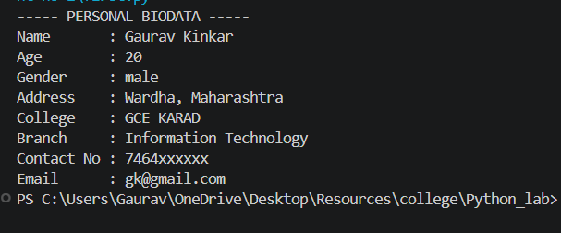
2) Program to perform arithmetic operations on two numbers
a = int(input("Enter first number: "))
b = int(input("Enter second number: "))
print("Addition:", a + b)
print("Subtraction:", a - b)
print("Multiplication:", a * b)
print("Division:", a / b)
print("Modulus:", a % b)
print("Exponent:", a ** b)
print("Floor Division:", a // b)
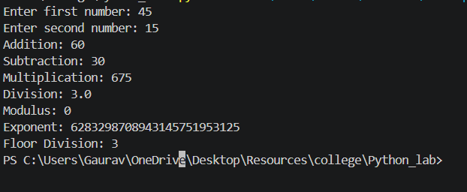
3)Swapping using temporary variable
a = int(input("Enter first number: "))
b = int(input("Enter second number: "))
print("Before swapping:")
print("a =", a)
print("b =", b)
# Swapping logic
temp = a
a = b
b = temp
print("After swapping:")
print("a =", a)
print("b =", b)
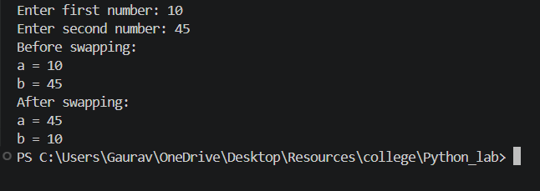
4)Program to calculate Simple Interest
P = float(input("Enter Principal Amount: "))
R = float(input("Enter Rate of Interest: "))
T = float(input("Enter Time (in years): "))
# Formula for Simple Interest
SI = (P * R * T) / 100
print("Simple Interest =", SI)
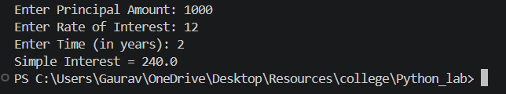
5)Program to convert Celsius to Fahrenheit
celsius = float(input("Enter temperature in Celsius: "))
# Conversion formula
fahrenheit = (celsius * 9/5) + 32
print("Temperature in Fahrenheit =", fahrenheit)
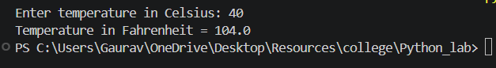
6)Program to calculate area and perimeter of a rectangle
length = float(input("Enter length of rectangle: "))
breadth = float(input("Enter breadth of rectangle: "))
# Calculations
area = length * breadth
perimeter = 2 * (length + breadth)
print("Area of Rectangle =", area)
print("Perimeter of Rectangle =", perimeter)
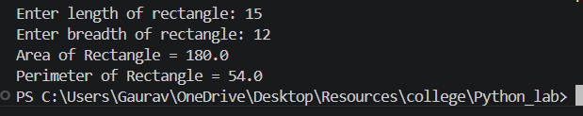
7)Program to check if a number is positive, negative or zero
num = float(input("Enter a number: "))
if num > 0:
print("The number is Positive")
elif num < 0:
print("The number is Negative")
else:
print("The number is Zero")
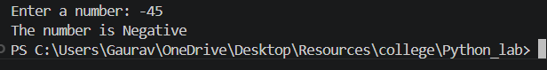
8) Program to convert days into years, weeks and days
days = int(input("Enter number of days: "))
years = days // 365
remaining_days = days % 36
weeks = remaining_days // 7
remaining_days = remaining_days % 7
print("Years:", years)
print("Weeks:", weeks)
print("Days:", remaining_days)
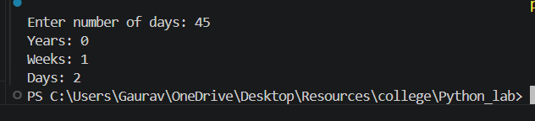
9)program to calculate square and cube of a number
num = int(input("Enter a number: "))
square = num * num
cube = num * num * num
print("Square of", num, "is:", square)
print("Cube of", num, "is:", cube)
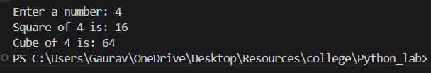
10)Program to demonstrate relational and logical operators
a = int(input("Enter first number: "))
b = int(input("Enter second number: "))
print("Relational Operators Demonstration")
print("a > b :", a > b)
print("a < b :", a < b)
print("a == b :", a == b)
print("a != b :", a != b)
print("a >= b :", a >= b)
print("a <= b :", a <= b)
print("\nLogical Operators Demonstration")
print("a > 0 and b > 0 :", a > 0 and b > 0)
print("a > 0 or b > 0 :", a > 0 or b > 0)
print("not (a > b) :", not (a > b))
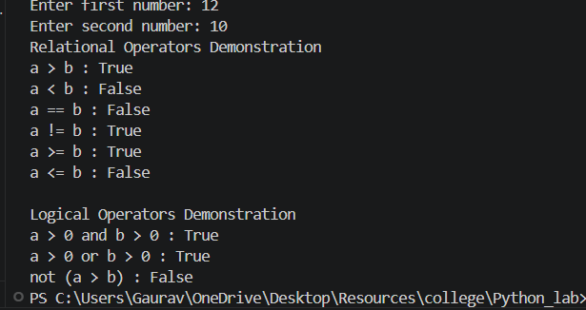

Conclusion
In this experiment, we studied the basics of Python programming, various data types, and different categories of operators. Understanding these fundamental concepts is essential for writing efficient Python programs.

